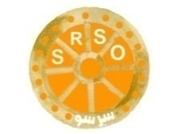
Livestock Insurance
Period 31-Dec-2026 to 30-Dec-2027

Sindh Rural Support Organization (SRSO) incorporated as a not-for-profit public company limited by Guarantee, registered under Section 42 of the Companies Ordinance, 1984. SRSO is an apex organization at the provincial level for poverty alleviation and the participatory development.
Sindh Rural Support Organization (SRSO) Require to Quotation of Livestock Insurance for an estimated 10,000 Animals.
Proposal
Sr. No | Quantity | Animal Category | Rate Required
1 | 10,000 | Cow
2 | 10,000 | Baby Cow
3 | 10,000 | Buffalo
4 | 10,000 | Baby Buffalo
5 | 10,000 | Sheep
6 | 10,000 | Baby Sheep
7 | 10,000 | Goat
8 | 10,000 | Baby Goat

Required cover on annual basis

